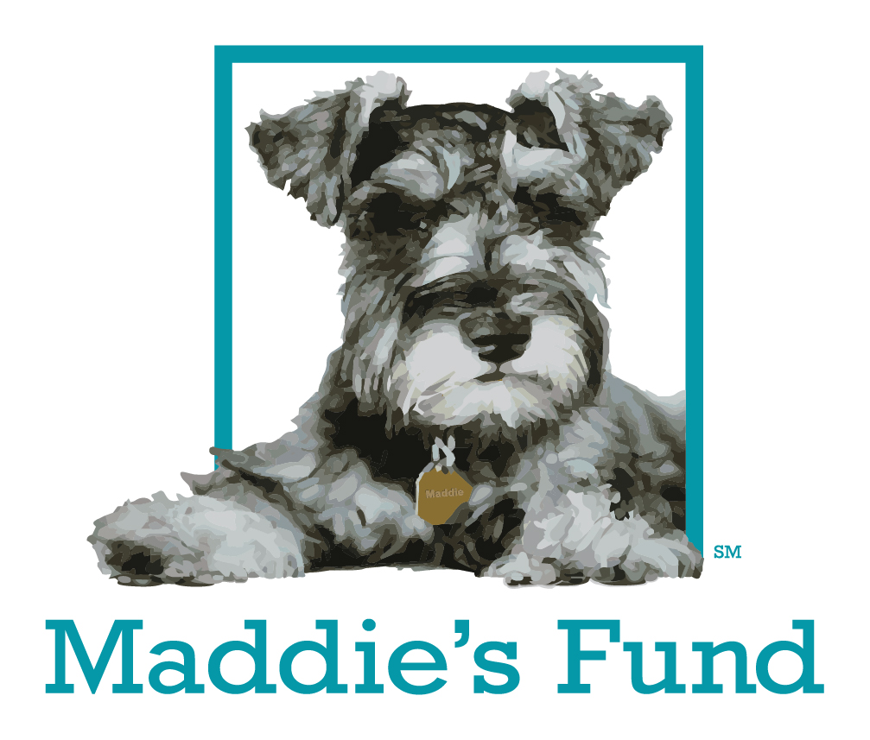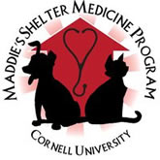

ASPCA or Maddie’s Fund

Shelter Medicine Externship Grant Opportunities 2017-2018

Veterinary students are encouraged to apply for either ASPCA or Maddie’s Fund Externship grants.

The ASPCA and Maddie’s Fund each provide grants of up to $500/week, for a maximum of two weeks, to assist with travel and housing expenses, to enable veterinary students to complete externships at animal shelters in the US. It is anticipated that there will be 10-15 grant opportunities available per year.
- ASPCA funds may be used to support work at animal shelters or humane organizations that employ at least one full-time veterinarian who will be supervising the student. Experiences must include more than spay neuter.
- Maddie’s Fund grants are restricted to externships at no-kill shelters and humane organizations employing a full-time veterinarian. Experience must include more than spay neuter.
Application: please send a resume and a statement of intent which includes which grant you are applying for, the name, mission, and location of the organization with which you will be completing the externship, the duration of the externship, the proposed budget for the experience, the name of the supervising veterinarian, and what you hope to learn from your externship experience.
Email the above to the Cornell Maddie’s® Shelter Medicine Program at: sheltermedicine@cornell.edu. Include “Externship Grant Application” in the subject line. Applications must be submitted a minimum of 2 months prior to the departure date and will receive notification of their award by email.

Post-externship: Recipients of the grant are required to submit electronically a 1 page summary of their experience and 2 photos which can be used for publicity purposes to sheltermedicine@cornell.edu . Additionally, original receipts attached to a travel reimbursement form must be submitted to Brenda Payne at s1-053 Schurman Hall. Only receipted expenses will be reimbursed.

